The Knowledge Base is designed to assist customer service representatives as they answer questions and resolve cases. It is a repository of information that is used by the customer service team but is visible to everyone. It consists of articles (documents) that are categorized by subjects.
These subjects are used to organize cases, products, and knowledge base articles.

To learn more about working with the Microsoft Dynamics 365 knowledge base, jump to the following sections:
•How to add subjects
•How to add article templates
•How to create an article

- How to Add Subjects to Dynamics 365:
1. On the Navigation Bar, click Settings navigate to the Service Management section.

2. Within the main screen, click Subjects. This will open a new window. View Add Subjects in CRM 2011
3. Within the Common Tasks section, click Add a Subject.
4. Within the Add Subject window, the title of the subject is required. The title is the name of the subject.

- How to add article templates
1. On the Top Navigation Bar, click Settings.
2. On the Top Navigation Bar, click Templates.

3. From the template page, click Article Templates.
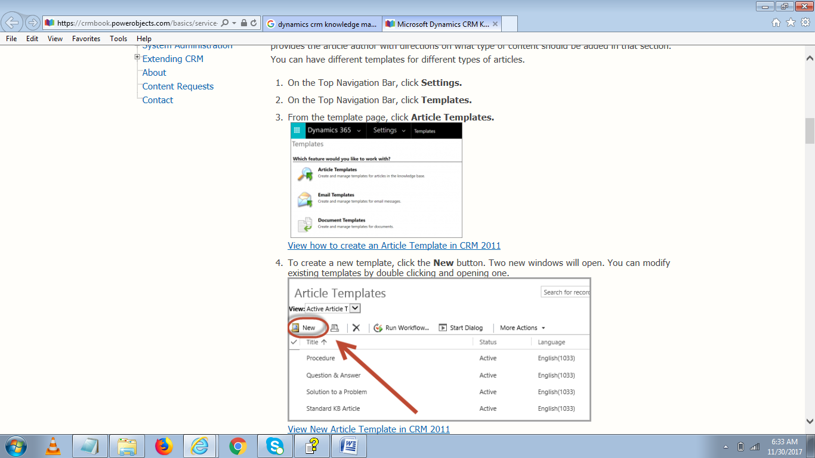
5. On the first smaller window it is required to name your template.
6. You can also add a description and select which language you would like the template to be in.
7. Once you’ve completed the applicable fields, select OK
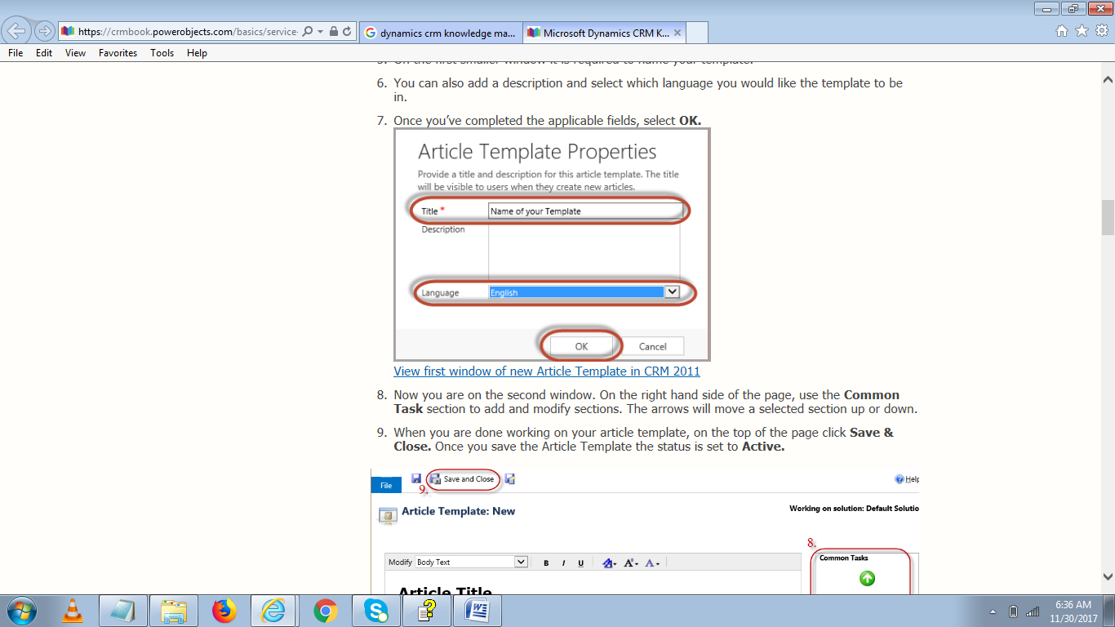

8. Now you are on the second window. On the right hand side of the page, use the Common Task section to add and modify sections. The arrows will move a selected section up or down.
9. When you are done working on your article template, on the top of the page click Save & Close. Once you save the Article Template the status is set to Active.

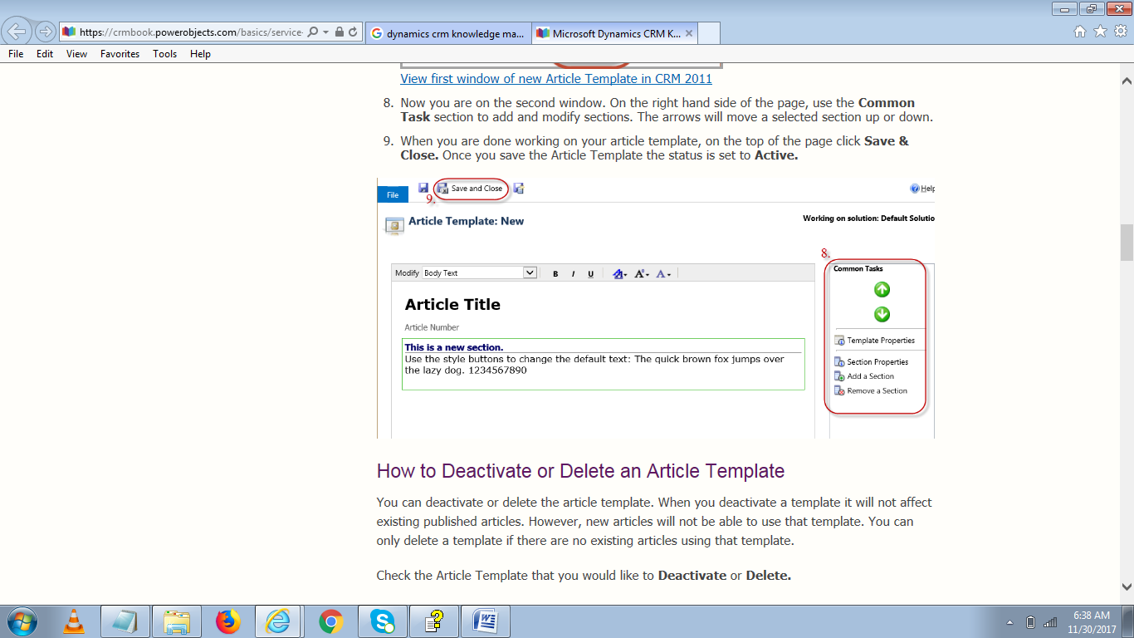

How to Create an Article

The Article is a document that helps customer service representatives resolve cases. Articles have to go through an approval process. Most users cannot see articles until they are approved. Articles can have the status of draft, unapproved or approved.
1. On the Top Navigation Bar, click Service.
2. On the Top Navigation Bar, click Articles.
3. To create a new article, on the top command bar, select New. A new window will open.
4. The next window that will open is where you can select which article template to use. Once you have selected your template click OK, and a new window will open.
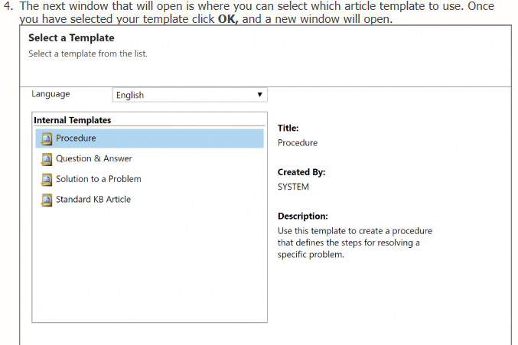
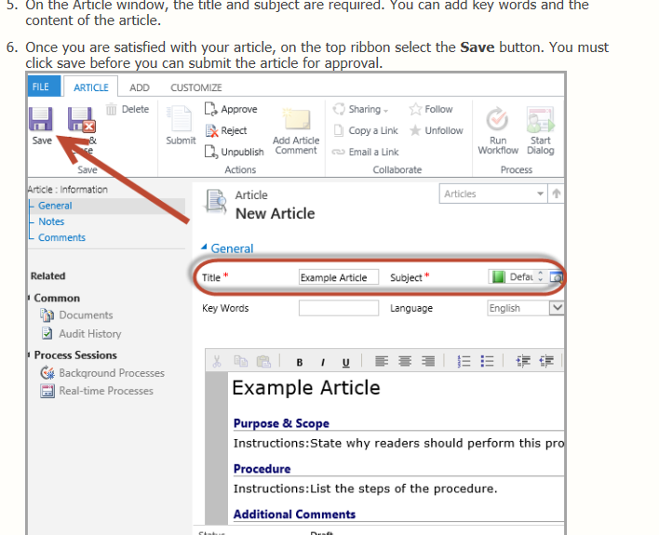
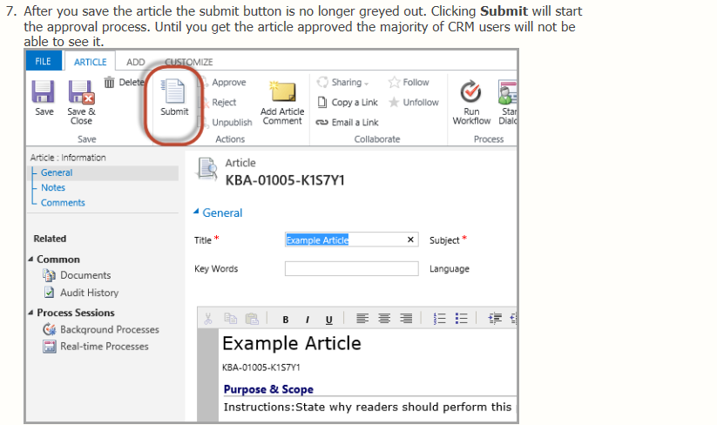
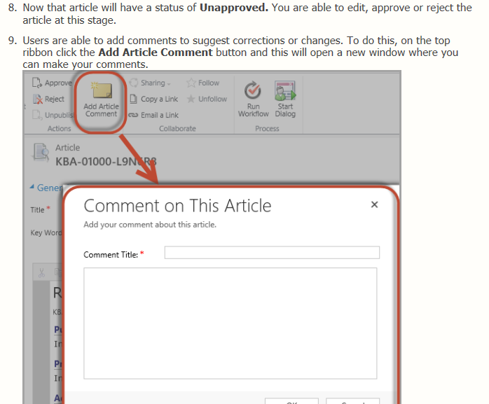
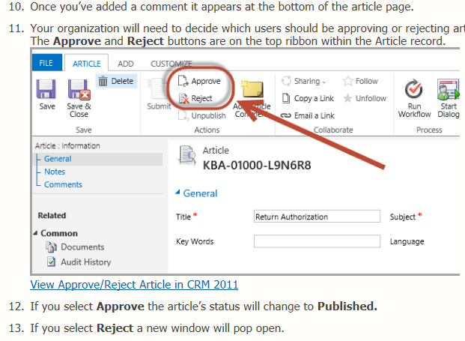

The new knowledge articles in Microsoft Dynamics 365 enable you to create rich knowledge articles along with versioning and translation support. When you create and publish a knowledge article, it become available to users in your Dynamics 365 instance so that they can use information in the articles to effectively service the customers.
Microsoft Dynamics 365 (online & on-premises) introduce a new knowledge management system that lets you create rich knowledge articles with support for embedding external multimedia contents, such as images and videos, as links
Contains the data that is needed to search for knowledge base articles that contain the specified keywords.

During its lifecycle, a knowledge article can be in the following states:
- 0: Draft (after a knowledge article is created)
- 1: Approved (after a knowledge article is approved)
- 2: Scheduled (after a knowledge article is scheduled to be published)
- 3: Published (after a knowledge article is published)
- 4: Expired (after a knowledge article is expired as per the expiration date specified while publishing)
- 5: Archived (after a knowledge article is archived)
- ‘6: Discarded (after a knowledge article is discarded)
Subject
A subject categorizes entity records, such as articles and sales literature. By using subjects, you can create a hierarchy of topics to organize and maintain information in Microsoft Dynamics 365. The information organized in the subject tree can be used by any entity in Microsoft Dynamics 365. The Subject entity categorizes the following:
- Knowledge base articles
- Incidents (cases)
- Product catalog items
- Sales literature
The content organization of the knowledge base is displayed in the subject tree. The subject tree provides organizational consistency across entities. It makes the system easier for customer service, sales, and marketing to use.

